Paterson Inquirer
David Paterson School Mission Statement
The David Paterson IB PYP Candidate Elementary School is committed to building partnerships with students, staff, parents and the community to develop life-long learners. Through rigorous inquiry and empowerment, our learners will be equipped to become college and career ready and exemplify attributes and skills of a 21st century global citizen.

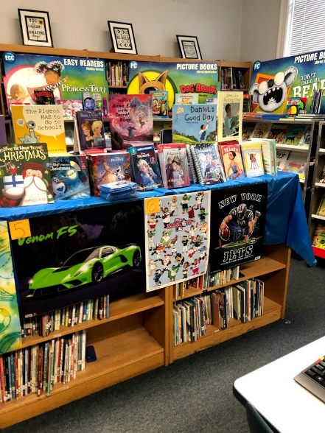
Every Child, Every Chance, Every Day!
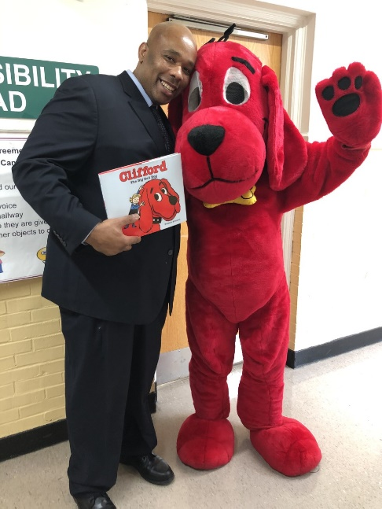  Principal Mr. Gary Rush  Administrative Message  Hello Paterson Family. We want to express how excited we are about all the great things happening at David Paterson. We are extremely proud of our students and staff. They have been instrumental in our journey as an IB PYP candidate school, where Inquiry and Student Autonomy are the top priorities. Our Learner Profiles for the last 3 months were Communicator, Balanced, and Open Minded which all contribute to great citizenship.  Perseverance could also be used as we had a 20% increase in the number of I-Ready lessons being completed and passed by students in grades 1-6. It’s important to continue allowing your child to log on at home as it will accelerate learning. Our morning 5th and 6th grade Math challenge has been very intense as class partners challenge each other in the 24 Math game. Reading is an essential part of learning. We want all students to read daily at home as the Read for Success committee will acknowledge students making the commitment to read daily. We want to thank all parents who were able to attend Coffee With The Principal, Student of The Month, Literacy Night for 1st grade and Parent Teacher Conference for the 2nd quarter. Parental support is important and needed for students to excel.  Some of our upcoming student writing initiatives include Senator for a Day, Be Kind to Animals and a Poetry contest. Each writing assignment includes acknowledgement and or prizes if a student’s writing is selected. We are committed to community involvement also as we had classes sign up for PSEG “Be empowered” challenge and write letters to nursing homes. The aforementioned are just a few of the many great things happening here at David Paterson. This time of year is crucial as we have upcoming state test in March, April, May and June. Do all you can to make sure they attend school daily? Together let’s continue to make greatness happen for Every Child, Every Chance, Every Day.  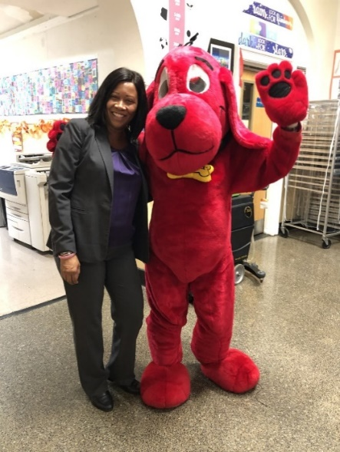  Warm regards,  Mr. Rush & Ms. Keller    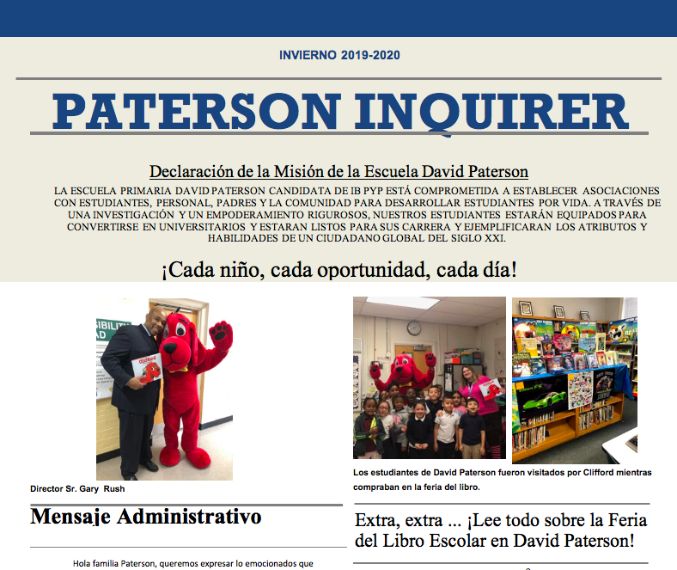 | 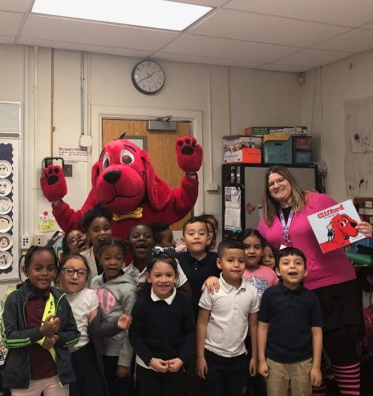  Students at David Paterson were visited by Clifford as they shopped at the book fair.  Extra, extra …Read all about the Scholastic Book Fair at David Paterson!  By: Tay ’Quan Hughes – 5th Grade Student at David Paterson Elementary School
 | As many of you already know, David Paterson had its Scholastic book fair in November. The book fair took place in the Media Center and was organized by Ms. Molinari our Media Specialist.  This book fair was very exciting and extremely successful. Let's start off with the most important information, the books! There was a huge selection of books in all genres: science-fiction, fiction, non-fiction, poetry. Let’s take one of the books for example. ‘’Captain underpants’’ was an often-picked fiction book.  Another jaw dropping surprise that took place in during the book fair was our special guest. No one was expecting him to make an appearance, but David Paterson was visited by the big dog himself, Clifford! Yes, you read that right Clifford the big red dog was at our schoolbook fair! | Being that this was my first book fair at David Paterson school, it was amazing on how awesome it was. I can only imagine how new students will feel if they attend our next book fair. Also, the book fair had so many books that kids like me would recommend reading like the “Dog Man” series. Also, the prices of the books were very affordable which I thought was very responsible of the school. But I think the best part of the book fair was how much fun the students at David Paterson were having. I look forward to seeing you at our next book fair!
 |  | 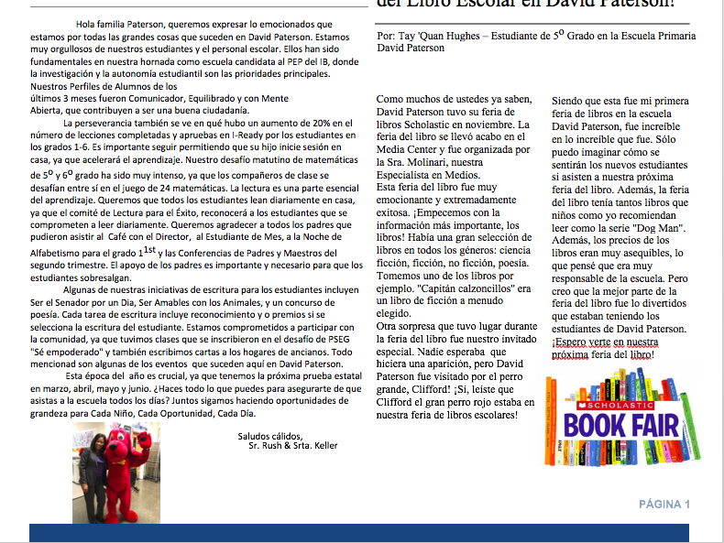
International Baccalaureate (IB) Primary Years Program (PYP)
Coaches’ Corner



We are excited to enter phase 2 of our journey as an IB PYP Candidate School. The mission of the International Baccalaureate aims to develop inquiring, knowledgeable and caring young people who help to create a better and more peaceful world through intercultural understanding and respect.
To this end the organization works with schools, governments and international organizations to develop challenging programs of international education and rigorous assessment.
These programs encourage students across the world to become active, compassionate, and lifelong learners who understand that other people, with their differences, can also be right.
Our school mission statement: David Paterson School is committed to building partnerships with students, staff, parents and the community to develop life-long learners. Through rigorous inquiry and empowerment, our learners will be equipped to become college and career ready and exemplify attributes and skills of a 21st century global citizen.
The Primary Years Program (PYP) includes the essential components: knowledge, conceptual understandings, skills, and attributes. Our teaching and learning promote learner agency where our students have voice and choice and act using authentic, real-life tasks.
Join us on our journey to the IB World by inquiring, communicating, acting and reflecting on:
- Our school brochure | - School website
- Our essential agreements | - monthly learner attributes calendar
- Parent learner profile activity packet | - School newspaper
- Become Part of our PTO | - Check out our PYP for You and Me Bulletin Board and our vestibule
- Communication Corner Bulletin Boards | - Parent Academies
- Bring Your Parent to School Days | - Family Game Nights
- Parent Teacher Conferences | - Student Action Form
- Assemblies/Events | - Concerts
Please take notice of student agency (action, voice and choice) that is taking place to promote global-mindedness in our school, at home, in the community, and the world!
Together as a school learning community, we strive to be balanced, caring, communicators, inquirers, knowledgeable, open-minded, principled, reflective, risk-takers, and thinkers!
David Paterson School proudly welcomes this candidacy status and your participation and cooperation in our school transformation to become the first authorized International Baccalaureate School on Long Island!
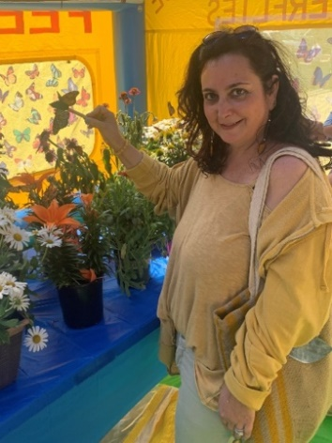
Respectfully,
Mrs. Amos
David Paterson PYP Coach

Bachillerato Internacional (IB) Programa de la Escuela Primaria (PYP)
Esquina de la Entrenadora

Estamos entusiasmados de entrar en la fase 2 de nuestro viaje como una escuela candidata del IB PYP. La misión del Bachillerato Internacional tiene como objetivo desarrollar jóvenes inquisitivos, conocedores y atentos que ayuden a crear un mundo mejor y más pacífico a través de la comprensión y el respeto intercultural.
Con este fin, la organización trabaja con escuelas, gobiernos y organizaciones internacionales para desarrollar programas desafiantes de educación internacional y evaluaciones rigurosas.
Estos programas alientan a los estudiantes de todo el mundo a convertirse en aprendices activos, compasivos y de por vida que entienden que otras personas, con sus diferencias, también pueden tener razón.
Declaración de la misión de nuestra escuela: la escuela David Paterson se compromete a construir asociaciones con los estudiantes, el personal, los padres y la comunidad para desarrollar aprendices de por vida. A través de una investigación rigurosa y el empoderamiento, nuestros alumnos estarán preparados para prepararse para la universidad y la carrera profesional y ejemplificar los atributos y habilidades de un ciudadano global del siglo XXI.
El Programa de la Escuela Primaria (PEP) incluye los componentes esenciales: conocimiento, comprensión conceptual, habilidades y atributos. Nuestra enseñanza y aprendizaje promueven la agencia de aprendizaje donde nuestros estudiantes tienen voz y opciones y actúan usando tareas auténticas de la vida real.
Únase a nosotros en nuestro viaje al mundo del IB indagando, comunicándose, actuando y reflexionando sobre:
- Nuestro folleto escolar | - sitio web de la escuela
- Nuestros acuerdos esenciales | - calendario mensual de atributos del alumno
- Paquete de actividades de perfil de padres y alumnos | - calendario mensual de atributos del alumno
- Forma parte de nuestro PTO | - Consulte nuestro tablón de anuncios PYP para usted y para mí y nuestro portal
- Tableros de anuncios de la esquina de comunicación | - Academias para padres
- Traiga a sus padres a los días escolares | - Noches de juegos familiares
- Conferencias de padres y maestros | - Formulario de acción del estudiante
- Asambleas / Eventos | - Conciertos
¡Tenga en cuenta la agencia estudiantil (acción, voz y elección) que se está llevando a cabo para promover la mentalidad global en nuestra escuela, en el hogar, en la comunidad y en el mundo!
Juntos, como comunidad de aprendizaje escolar, nos esforzamos por ser equilibrados, atentos, comunicadores, indagadores, conocedores, de mente abierta, con principios, reflexivos, tomadores de riesgos y pensadores.
¡La Escuela David Paterson se enorgullece de agradecer este estado de candidatura y su participación y cooperación en nuestra transformación escolar para convertirse en la primera Escuela de Bachillerato Internacional autorizada en Long Island!
Respetuosamente ,
Mrs. Amos
David Paterson PYP Coach

International Baccalaureate (IB) Primary Years Program (PYP)

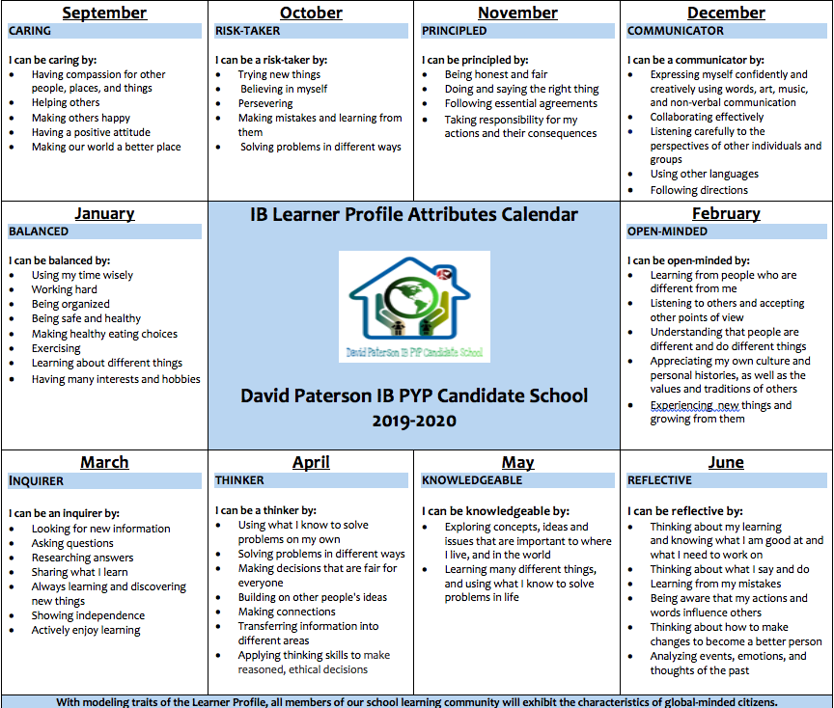

International Baccalaureate (IB) Primary Years Program (PYP)

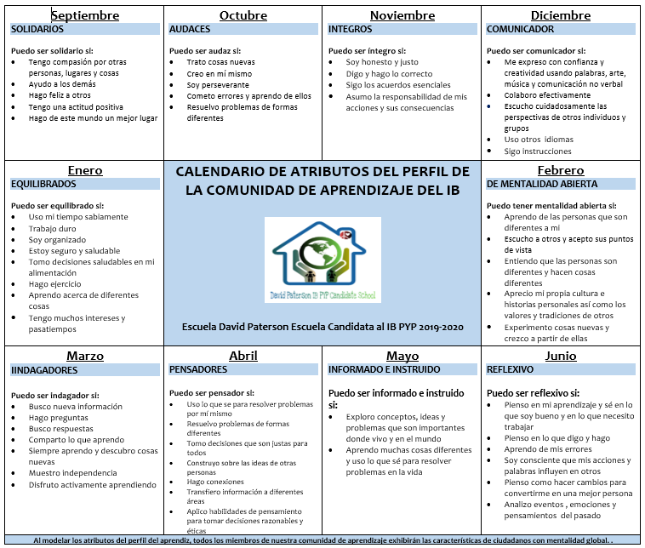

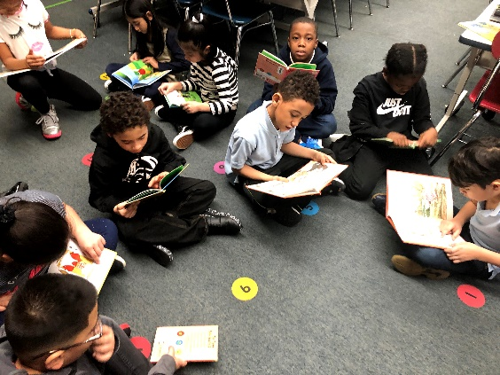
Media Happenings
By: Ms. Molinari
David Paterson’s Media/Instructional Technology Specialist

Upper Grades

Great things have been happening in Media class! Students in the third, fourth, fifth and sixth grade have been working on research projects that align with their Units of Inquiry. During the winter months, our students researched about diverse cultures and the holidays that they celebrate. Using Buncee, students created multimedia presentation to then demonstrate their knowledge of each culture’s holiday.
As we entered the month January, the third and fourth grade students researched about the planet, specifically focusing on ecosystems. This project directly aligned with the “Sharing the Planet” transdisciplinary theme. Students developed questions then used various resources to research, discover and inquire. Students in the fifth grade created environmental posters to deepen their understanding of how geography influences relationships amongst communities. Classes were able to research the different renewable and non-renewable resources that we depend on every day. Each grade created presentations that included informational text, images and animations to demonstrate their knowledge of the topic.

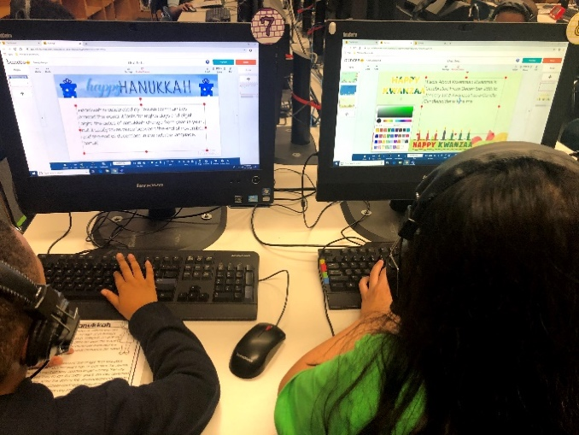
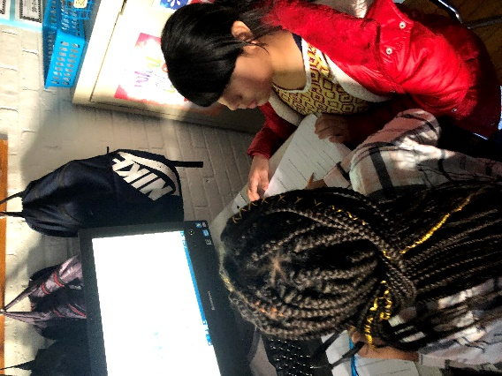
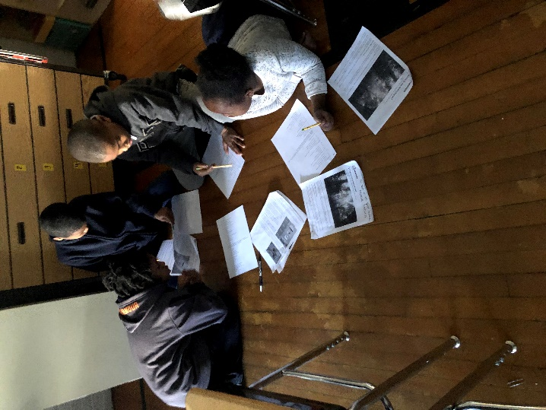
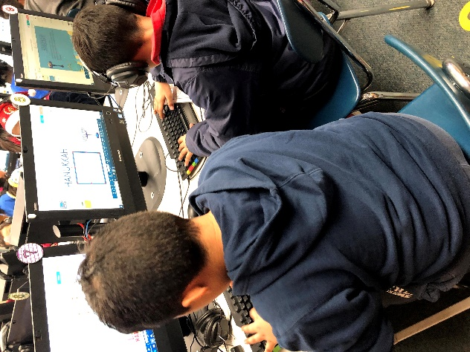

Lower Grades

Our first and second grade classes completed an inquiry into fables and fairytales from diverse cultures. Using various forms of media, students discovered new stories while also practicing skills that support grade level standards.

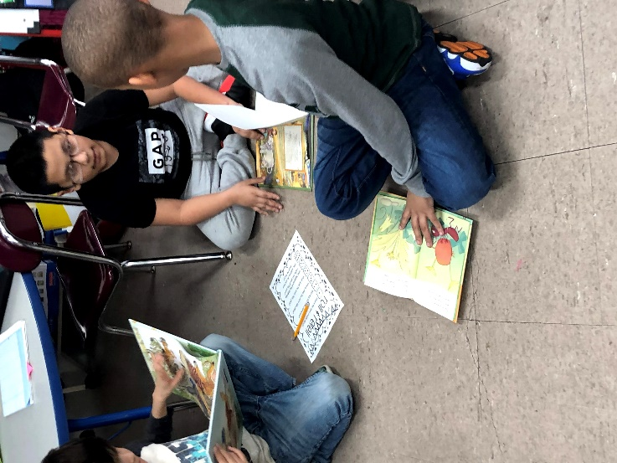
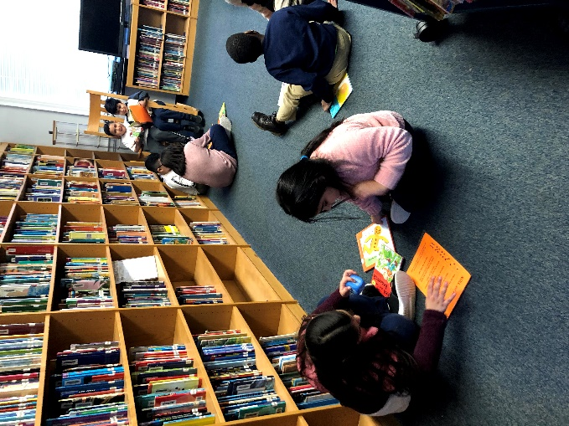
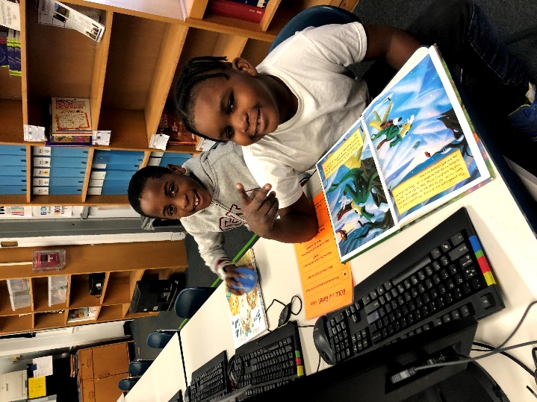
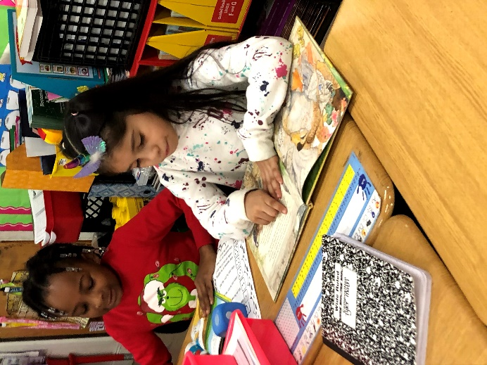

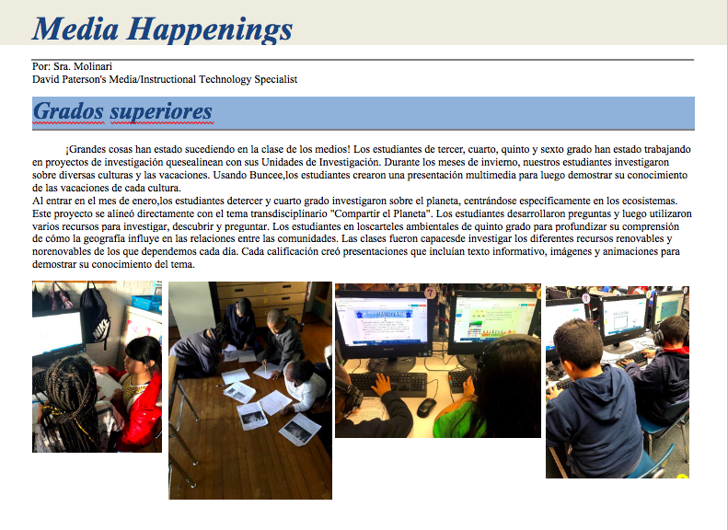
Media Happenings
By: Ms. Molinari
David Paterson’s Media/Instructional Technology Specialist

Grados superiores

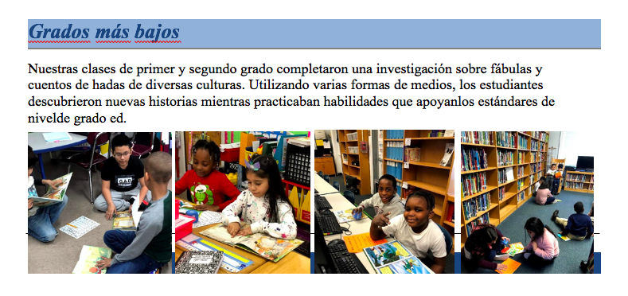

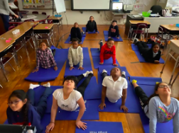
Features in Phys. Ed

By: Ms. Taglioni

David Paterson’s Physical Elementary Teacher

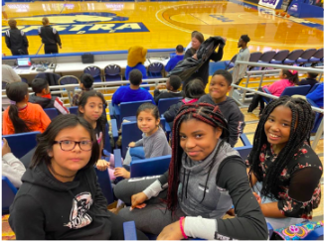
Balancing the Mind and Body with Yoga
Ms. Taglioni’s physical education classes have been participating in the first-ever yoga unit at David Paterson! Throughout the unit, students have been learning about the importance of balancing the intellectual, physical, and emotional aspects of their lives. Students have learned how to perform a variety of yoga poses, including upward salute, downward facing dog, and bow pose. As a result of implementing yoga into the physical education program, balance and coordination skills have increased among students. Not only were students able to follow along with the teacher-demonstrated sequences, but they ended the yoga unit by working together in small groups to create their own yoga sequence to lead and teach the class. While creating a peaceful and relaxing environment, students also practiced strategies for being mindful. All these skills contribute to teaching our students how to develop a balanced, healthy life.

Hofstra Women’s Basketball Education Day
This quarter, students at David Paterson Elementary had the opportunity to attend a field trip at Hofstra University. Hofstra University was celebrating its Women’s Basketball Education Day. The objective of the field trip was to educate the students about the importance of balancing various components of life. As a student-athlete, there are extraordinary responsibilities, some of which include earning good grades, getting enough sleep, exercising and training. Knowing how to balance your time and priorities is critical for a successful academic and athletic career. We concluded our Hofstra trip with a women’s basketball game against William and Mary College.

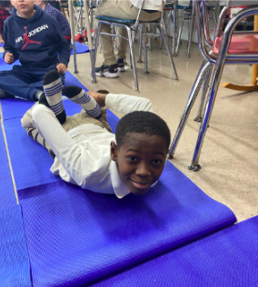

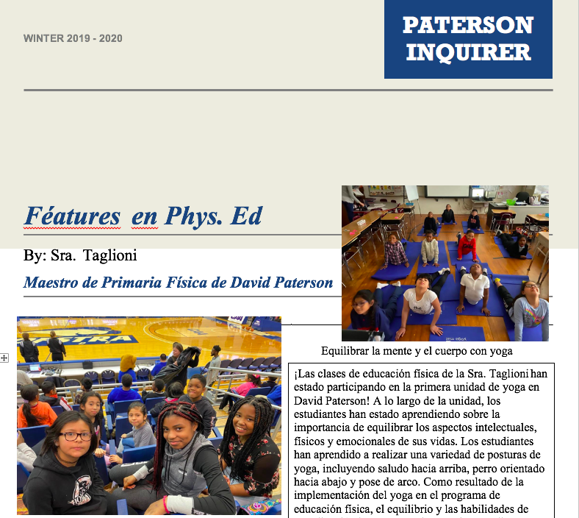
Features in Phys.Ed.

By: Ms. Taglioni

David Paterson’s Physical Elementary Teacher

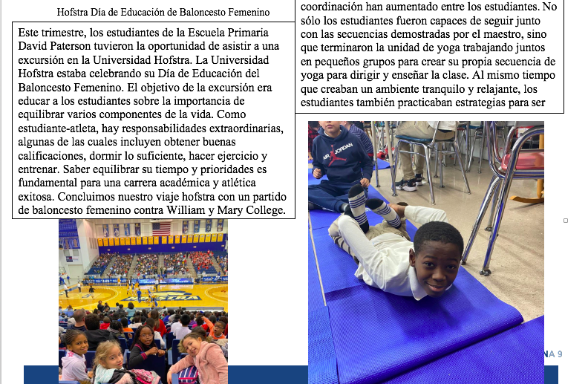

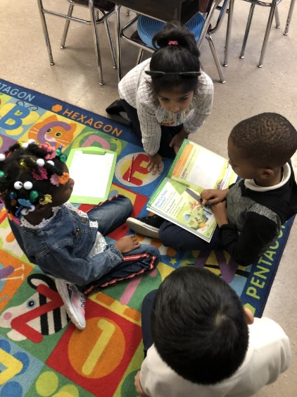

Grade 1 News
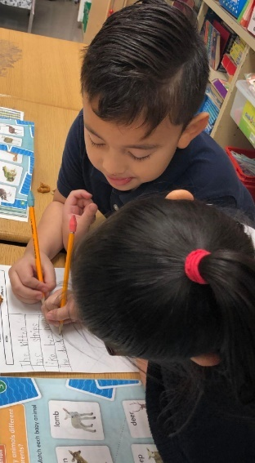
1st Grade Wonderings…

Unit Theme: How We Express Ourselves
Central Idea: Creative Expression Communicates Language

Lines of Inquiry…
- How imagination creates new ideas
- Life’s lessons from multiple media
- The importance of art and music

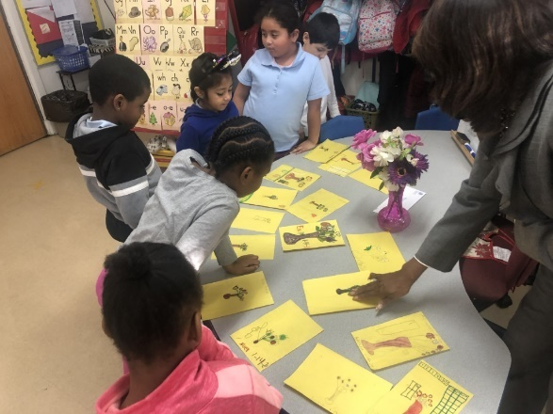
Ms. Riviere- During our “How we express ourselves” unit, it was important to me that my students had a true understanding of self-expression as it relates to art and imagination as reflected in the Lines of Inquiry. We jumped off the unit by reading the well-known children’s book Ish by Peter H. Reynolds; one of my personal favorites! In this book Ish expresses himself through poetry, words and more importantly art drawings. His confidence in his art work was put to the test, but in the end, he loved his art and continued to make cute drawings throughout the book. The book set the tone to inspire my students about being able to creatively express themselves in many ways. During our provocation, I simply asked my students to draw a still-life of my faux flowers inside of a vase, prior to reading the book. They did not know the next task would be to critique one another’s art. Finally, they would have to find something that they could communicate to each other that would show appreciate for one another’s artwork.

Mrs. Vaca-We recently finished the unit, “How we express ourselves.” The students had a lot of fun during this unit. They read many traditional folktales, and Aesop fables. They used their imagination to create their own fable. All these readings allowed us to focus on the life lessons we can learn from multiple media. The students showed the reflective attribute by analyzing characters from the stories and understanding what they teach us. We are looking forward to starting our next unit “Where We Are in Place and Time.”
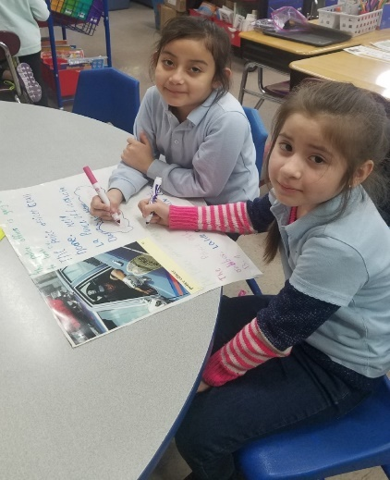
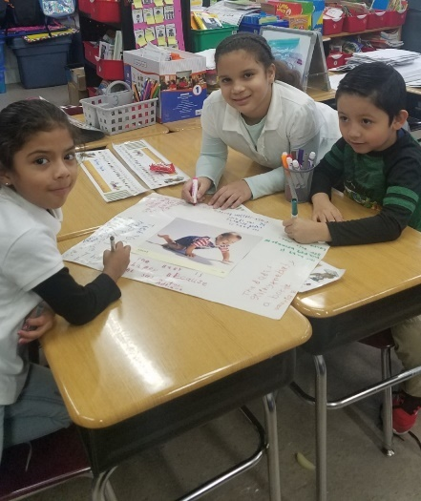

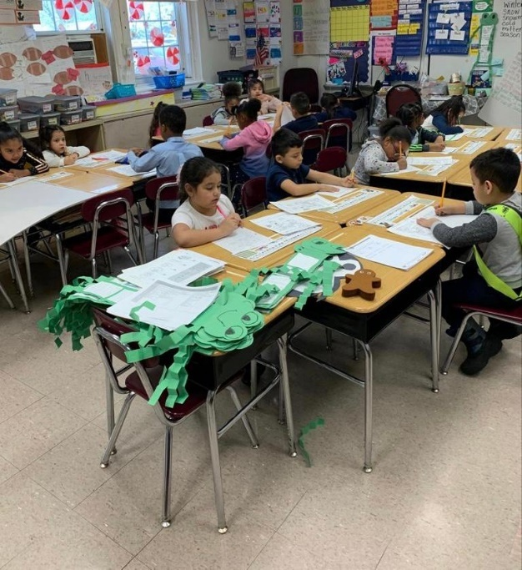

Mrs. Tavernise-Our class has just finished working on the Transdisciplinary Theme: How We Express Ourselves. The students are continuing to strengthen the profiles of being a communicator and being reflective. Our class is learning about folktales and fables. We have listened to several read alouds such as, The Tortoise and the Hare, The Ants and the Grasshopper, Stone Soup and many others. The students learned various life lessons through these stories.

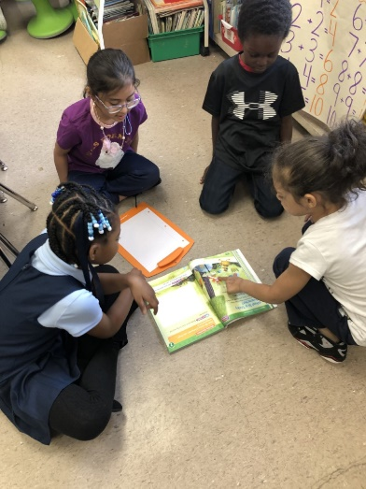
Ms. Pascarella & Mrs. Thompson- Our class is finishing up How We Express Ourselves. During this unit the students focused on thinking (learning new information and creating) and communicating (listening, speaking, viewing) through the use of fables and folktales. The students were able to express their thinking and learning through words, poetry, music, and art.

Ways to Encouraging Children to Express Themselves
- Teach kids how to express themselves in the arts.
- Encourage kids to have their own style
- Let kids explore their interests.
- Give them choices

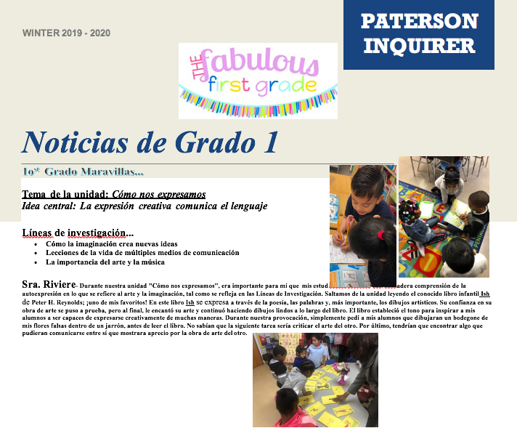

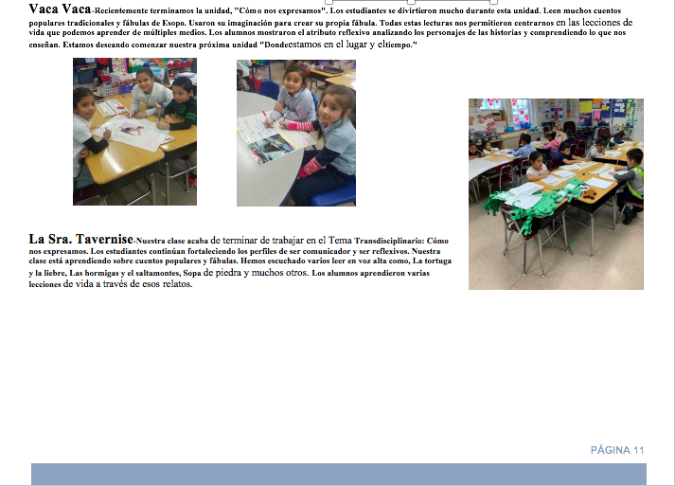

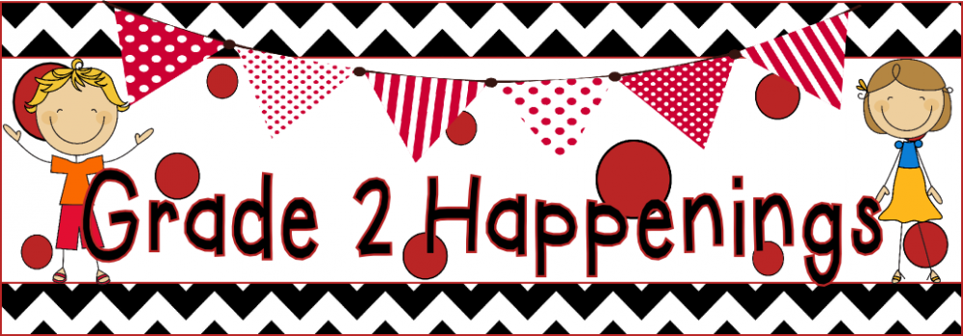

Grade two just finished the transdisciplinary theme How We Express Ourselves and are now learning about Where We Are in Place and Time.
Central idea: Changes and discoveries revitalizes humankind.

Lines of Inquiry:
- An inquiry into how the past affects the present
- An inquiry into how people's actions create change
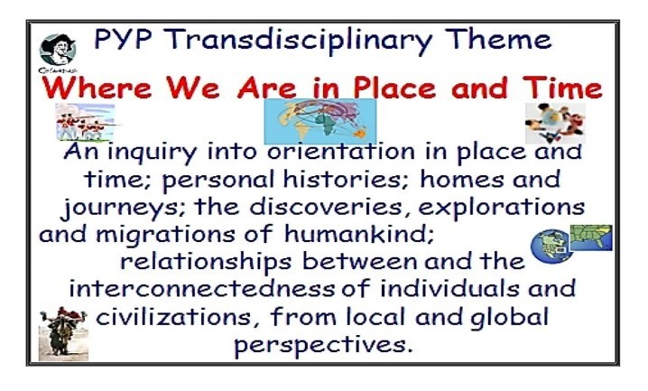
- An inquiry into how people work together to solve problems

Key Concepts:
Change, Causation

Related Concepts:
Discovery, Time, Values

Learner Profile:
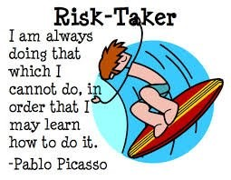
Risk-Taker, Knowledgeable
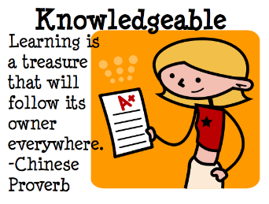
A Message from Mrs. Higgs Class and Teaching Assistant Ms. Morgan
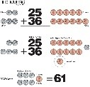
Happy New Year! Mrs. Higgs ’Second Grade Class is off to a great New Year. This Quarter, our Unit of Inquiry is, “Where We Are in Place and Time”.
This is a great Unit for Second Grade because it focuses on the Past as well as the Present. It tracks History, allowing students to see some of the ways and customs of how life was before they were born. There were many changes that took place over decades that bought us to a better place and time.
Some of the major changes that took place over time were Civil Right Laws to protect us, many great Inventions and technology that we benefit from today. Through our textbook (MY VIEW) and other resources such as ELA/SS resource, my students will continue to receive a transdisciplinary Education.

We have a great MATH program. It has interactive Math Starters that motivates our students to want to learn. The Go Math textbook is kid friendly and has many opportunities for students to be successful. I personally like the way each lesson starts off with a model for the teacher to share with the class. Sometimes I allow students to try to solve the problem alone and sometimes I read the problem to the class to see how they solve the problem. My students love watching the videos and responding to the questions and answering them before the animated Bear does. This is a sure way of engaging all students. They get so excited and motivated to learn when the videos are being played.

This month my two students that were chosen to represent our Learner Profile are Jefferson Rodriquez and Catherine Fuentes. Here is the way in which they show open minded.
Jefferson Rodriquez is open minded by solving two-digit Math problems in different ways from his peers using the Break apart Method.
Catherine Fuentes is open minded because she respected her fellow classmates who do not celebrate some of the holidays that she does.

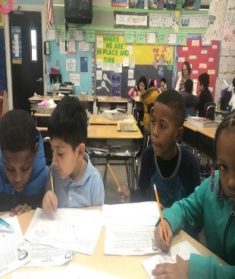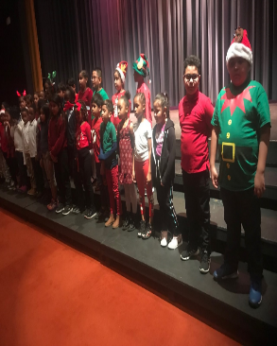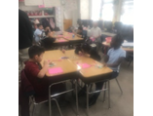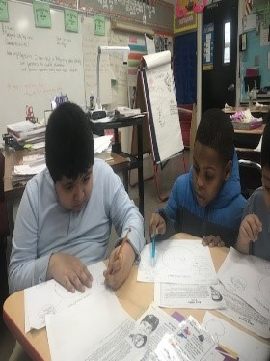

A Message from Ms. Diaz’s and Mr. Torres' Class
Our second-grade scholars are super excited to be halfway through the school year with so much knowledge and wonderful experiences thus far. They are positive to further expand their skills and knowledge in every subject area. They are ready to continue to practice and become more experienced writers, readers, and mathematicians. They are reading bigger and more complicated books, writing longer sentences and learning more about the concepts behind math skills. They are involved in research and critical thinking in small and large groups and sharing their information through class discussions, writing, and drawing.
This month our class will continue to develop their literacy skills as they learn more complex words and absorb longer, more rigorous texts in a variety of genres including fiction, non-fiction, and Narrative nonfiction. Students will also expand their reading comprehension skills as they ask and answer questions about what they read to deepen their understanding and gain more information about the text.
Our second-grade scholars will continue to practice addition and subtraction skills. They are doing great solving problems in their heads, writing addition and subtraction equations, decomposing, regrouping and representing numbers in various forms. They love to use math tools such as counters, blocks, number lines, and boards to help them practice these skills.
I encourage parents to continue reading with the children at home, ask them questions about the story, practice sight words and help them write longer sentences using proper capital letter and punctuation. Also, continue practicing the math skills we are learning in class by assisting children with the math homework every night.
Our Open-Minded students for this month are Michelle Avila and Robert Perdomo.
Keep up the good work scholars!

A Message from Ms.Stroughn and Ms.Challenor’s Class
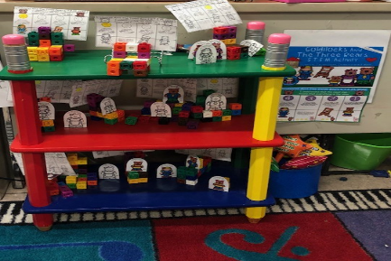
Our class is off to an extraordinary start. We are diligently working on meeting the 2nd grade standards. Our students are proud to say we are moving our reading levels and striving to meet our reading goals. In our previous International Baccalaureate Program Unit: How We Express Ourselves, Ms. Stroughn and Ms. Challenor’s class had the opportunity to explore fairytales, folktales and fables. Student’s asked thoughtful questions as we learned about morals and lessons. After reading Goldilocks and the three Bears, students showed compassion for Baby bear and his broken chair by completing a S.T.E.M (Science, Technology, Engineering and Math) activity. Students understand the problem and were given the opportunity to Design and test out the functional chair that they made for Baby Bear. Students could not use more than 30 cubes and had to measure the height of their chairs. Students were very creative and creating chairs that swung and that had a steep stool. We wanted our students to know that they are scientist, mathematicians, and inventors. We are so proud of their work.
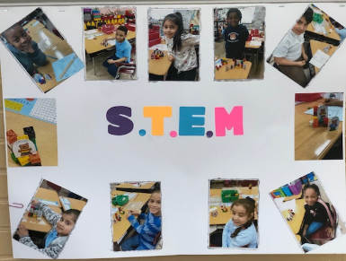

In Math our student will be working on Modules 4 and 5 using Engage NY. In Module 4, students develop place value strategies to fluently add and subtract within 100; they represent and solve one- and two-step word problems of varying types within 100; and they develop conceptual understanding of addition and subtraction of multi-digit numbers within 200. Using a concrete to pictorial to abstract approach, students use manipulatives and math drawings to develop an understanding of the composition and decomposition of units, and they relate these representations to the standard algorithm for addition and subtraction. In Module 5, students build upon their mastery of renaming place value units and extend their work with conceptual understanding of the addition and subtraction algorithms to numbers within 1,000, always with the option of modeling with materials or drawings. Throughout the module, students continue to focus on strengthening and deepening conceptual understanding and fluency.
Congratulations to our IB Learner Profile Representatives
Open- Minded: Scarlett Gomez and Keshawn Knight
Balanced: Tyler Palmer

A Message from Ms. Jones Class

Ms. Jones 2nd grade class is starting 2020 doing amazing things. We started our Unit of Inquiry "How We Express Ourselves.” We learned about fairytales and fables and how they have become part of many cultural traditions. The students were surprised to discover that some of the traditions they have in their homes were similar to their classmates.
Our students are also embarking the IB traits of open-mindedness, knowledgeable, caring and risk takers. We took a trip to the Tilles Center and saw a play based on fairy tales that the students have learned. They were able to connect what they learned in class to the what they saw in the play. Our students also created Letters to the Veterans, which enabled the students to learn what they have done for our country and how we can thank them for their service. We are counting up to the 100th day of school and will be doing a project to show what that milestone means to us. We have had some enlightening discussions about Black History Month and the people who have made an impact on their lives. Some of our students have greatly improved their reading levels and are very proud of the benchmarks they have achieved. We are now tackling two-digit subtraction in math. And I know we will be able to master that soon.
Congratulations to the following students for showing Open-Minded thinking Jace Higgins and Michael Daniel
Our class looks forward to the Spring semester at David Paterson.

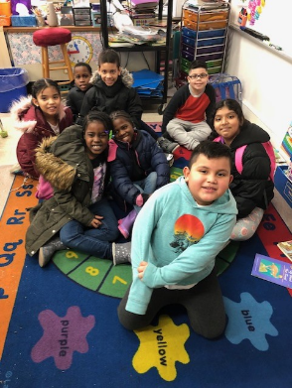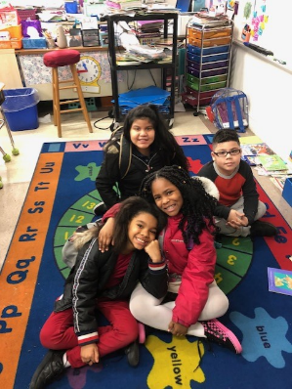
Ms. Jones and Ms.Ray

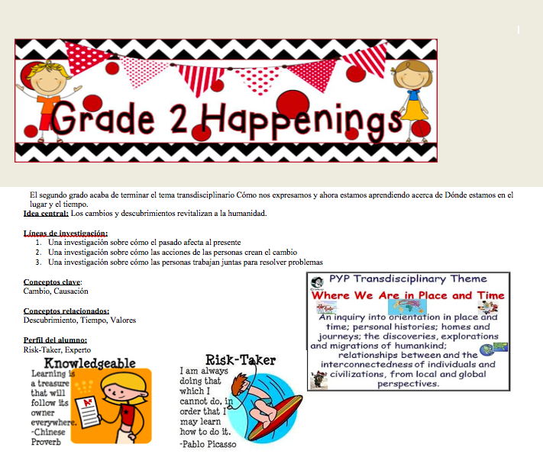

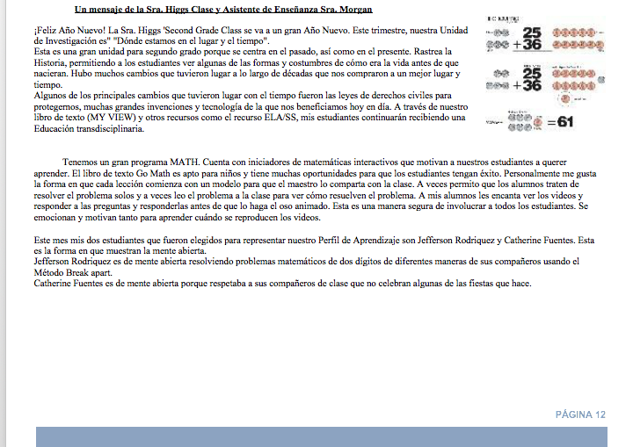

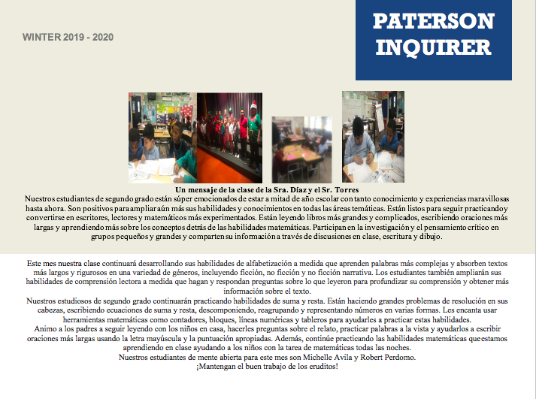

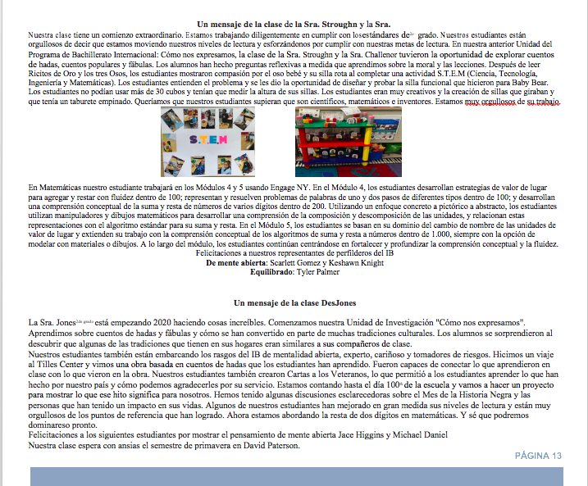

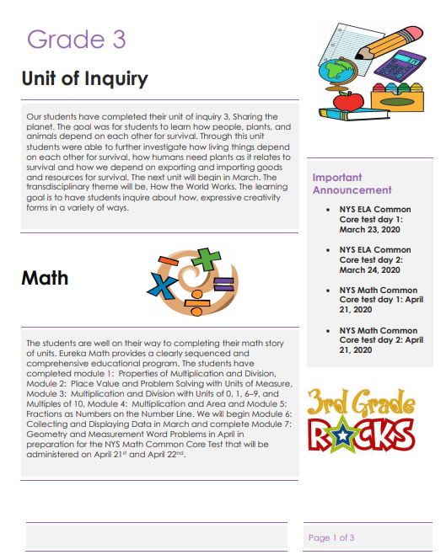
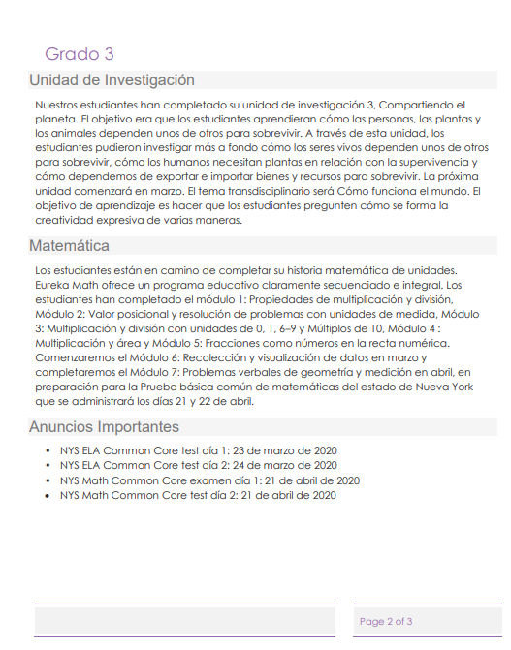

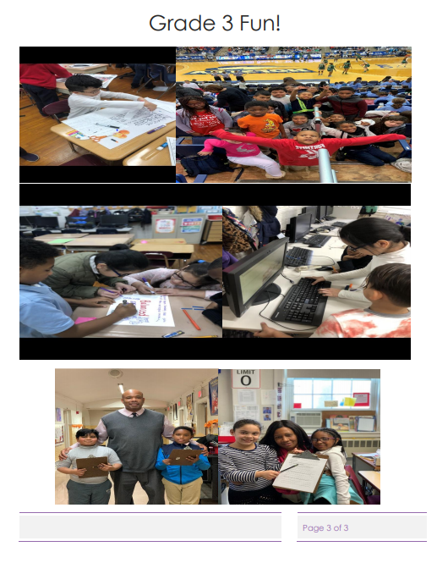

Fourth Grade Newsletter
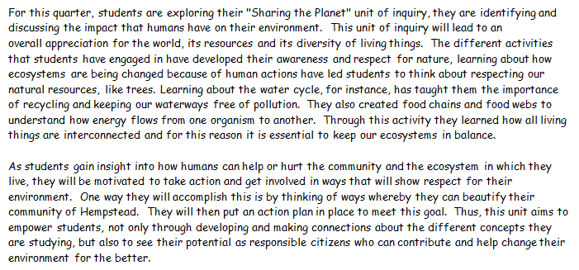
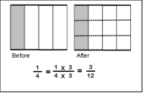

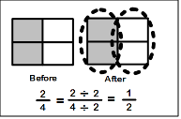
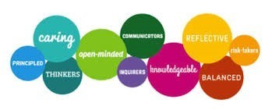

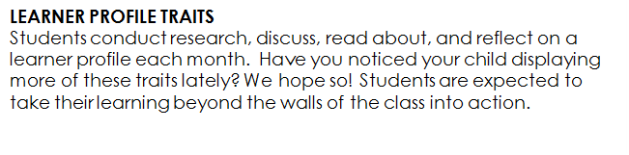
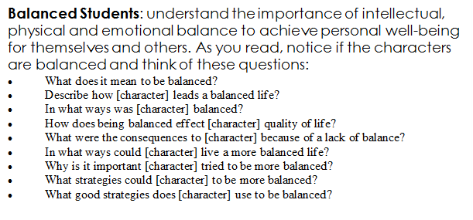
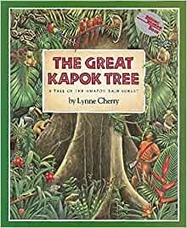
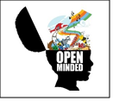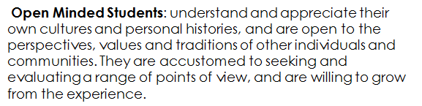
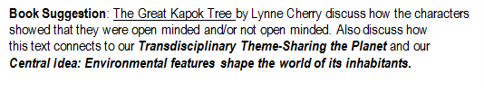

Children’s Programs
PLEASE REGISTER FOR ALL PROGRAMS IN THE
CHILDREN’S ROOM OR BY CALLING (516) 481-6990 ext. 15

Whalers Wanted for children in gr. 1 – 5- February 19th at 3:00 p.m.
Celebrate Black History Month by learning about the contributions of African-Americans in whaling, touch some of the navigational tools they used, and create a wooden ship!

Bubble Gum Workshop for children in gr. 1 – 5- March 28th at 3:00 p.m.
Create your very own bubblegum using science!

Does your child have a library card?
If not, contact the Hempstead Public Library to find out how you can get one!
516-481-6990
www.hempsteadlibrary.info


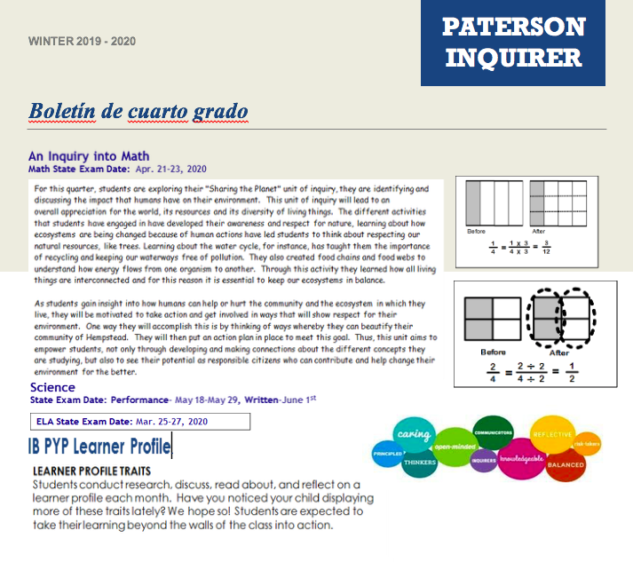

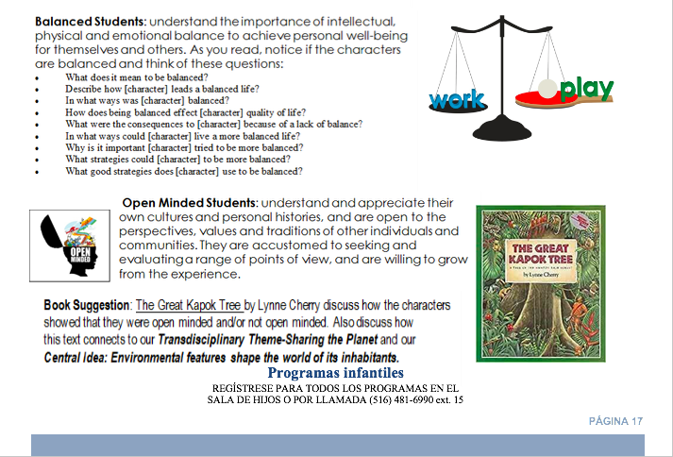

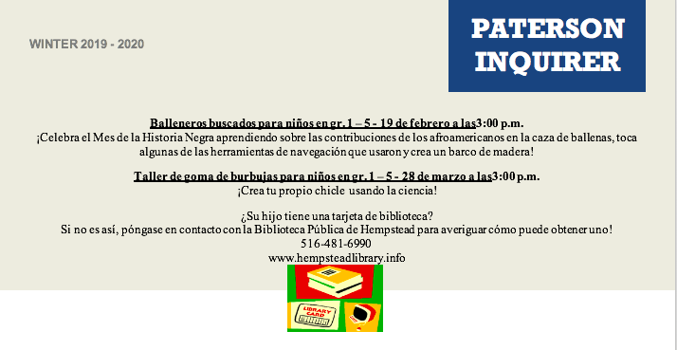

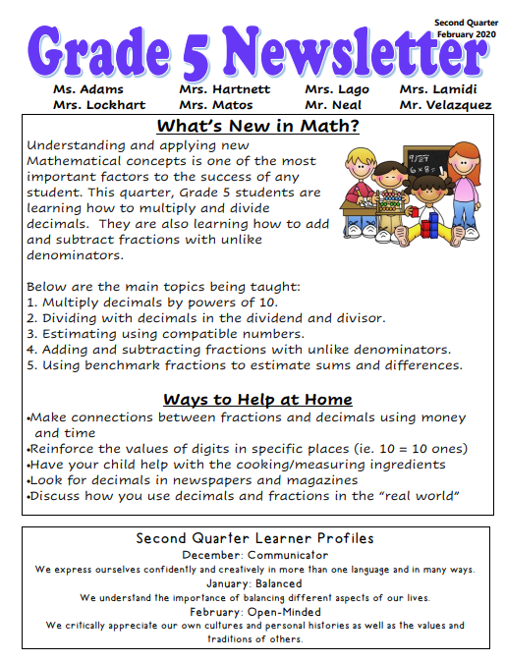

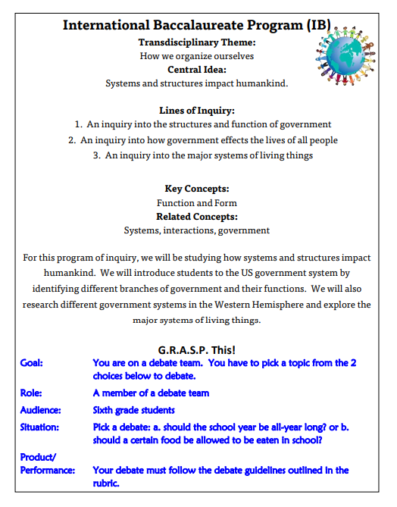

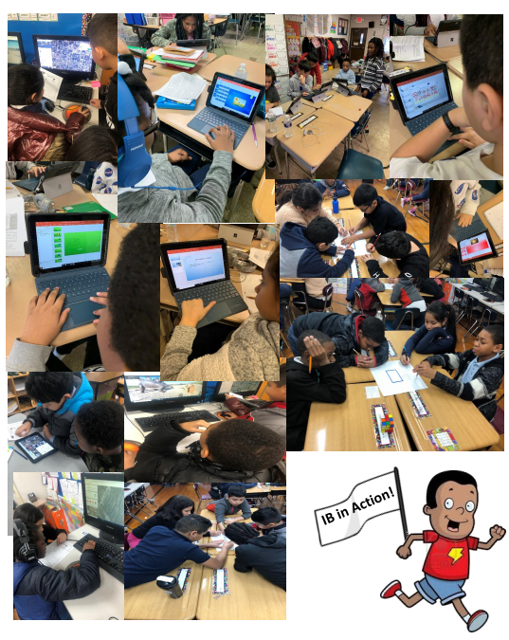

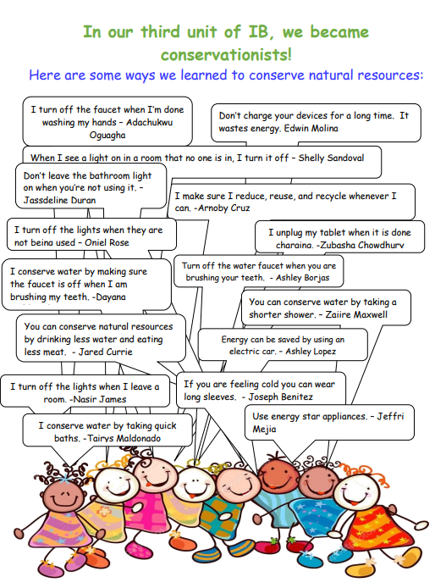

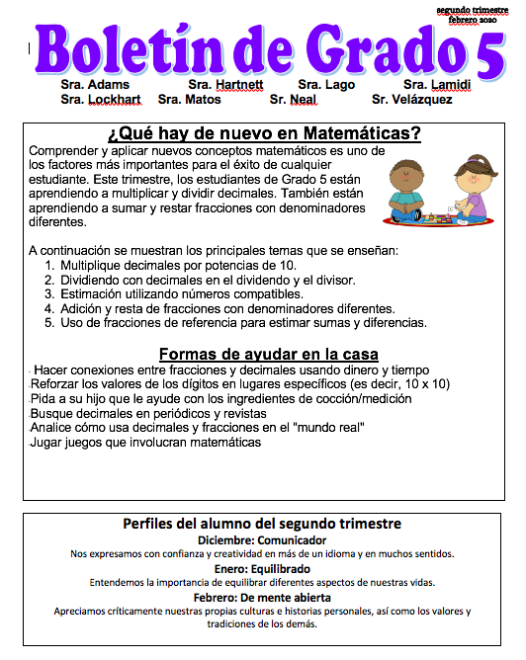

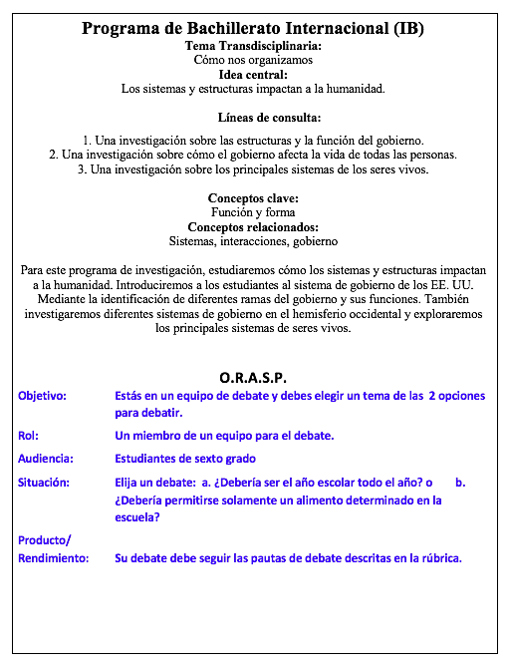

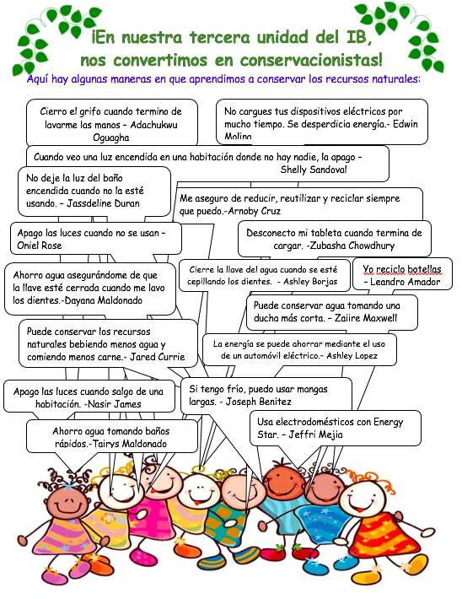

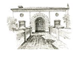
6th Grade IB Global Thinkers Academy

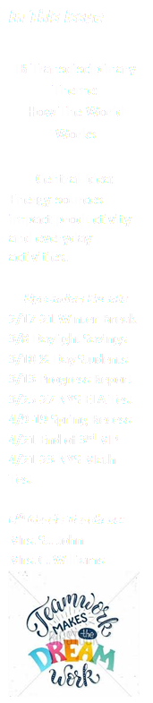
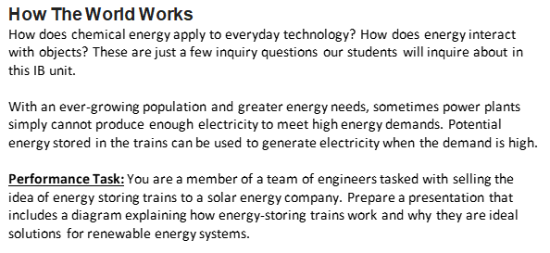

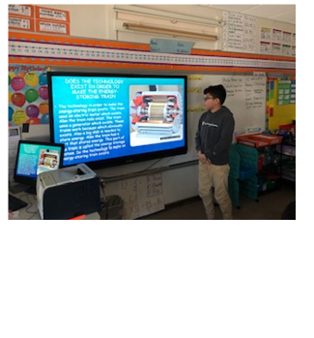
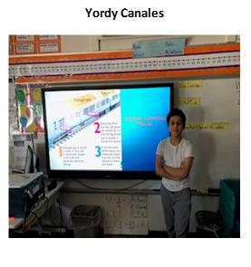

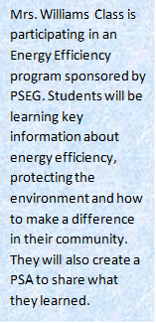

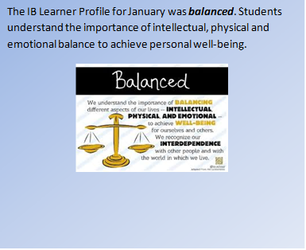

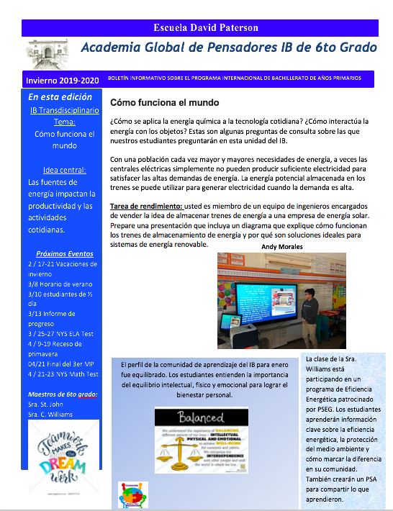

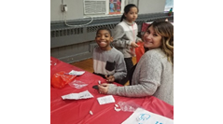
Holiday Make and Take
Hosted by 5th Grade
Five December 16, 2019

By: Allison Guarnero (Grade 4)
I was excited to create a holiday project during our “Make and Take. “As soon as I entered the multipurpose room, I was given a treat bag and told to sit at the table with the activity I chose. If we needed help, there were other students and teachers there to help us out. Making the craft was fun. I liked being able to choose the activity I wanted. In the treat bag, we had a candy cane, book, crayons and then we put our handmade craft inside to keep everything organized. It was fun!

By Kaylie Dubon
The Make and Take was special to me. It came with a goody bag filled with treats. Holidays are special. We get to celebrate and enjoy with our friends and families.
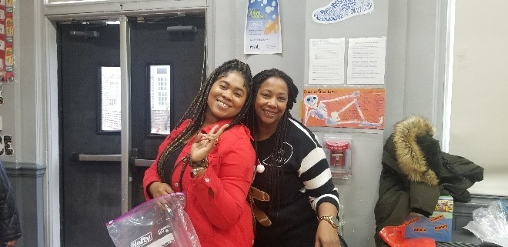
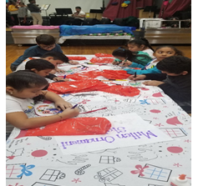

Social Work Department
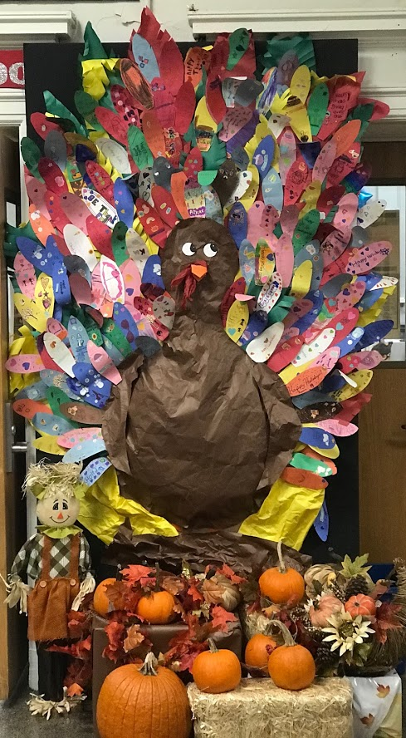
Special Holiday Food and Clothing Drive
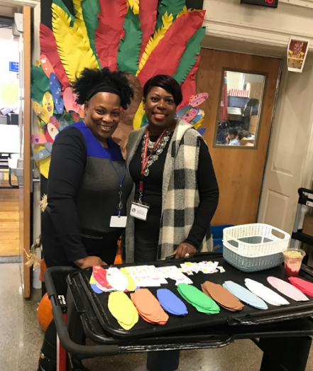
We want to wish all our families a Happy and Healthy New Year. Thank you to the David Paterson family for supporting our holiday events. David Paterson had an exciting season of giving and caring during the holiday months. We kicked off our campaign in November with our students participating in our “Thankful Turkey Project.” Students purchased a feather to decorate “Principled Patty” who was in desperate need of feathers. Because of the support and commitment of our students and being a part of a principled and caring community, we were able to raise $176.00!! These funds were used to purchase food items that placed in eight Thanksgiving Baskets. The baskets were then raffled off at our Parent Teacher Conference.
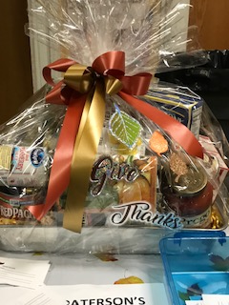

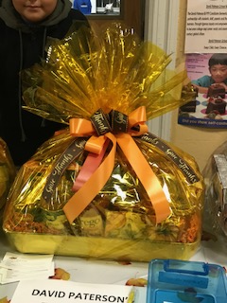
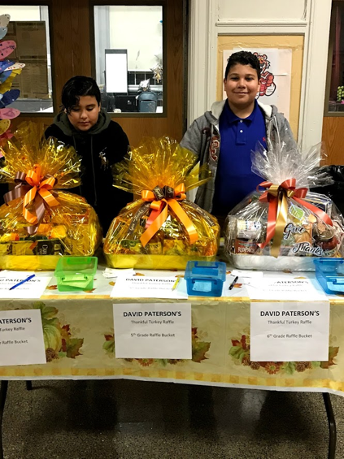
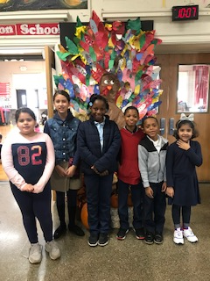

Coat and Clothing Drive
David Paterson staff, friends and community partners, joined to donate new or gently used & cleaned coats and winter clothing for our students. Throughout the months of November and December we were able to donate over 100 coats and winter clothing to our families in need.

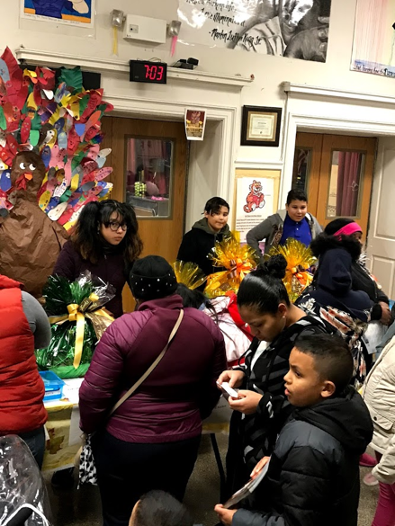
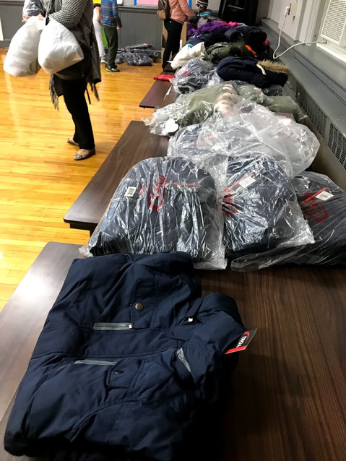

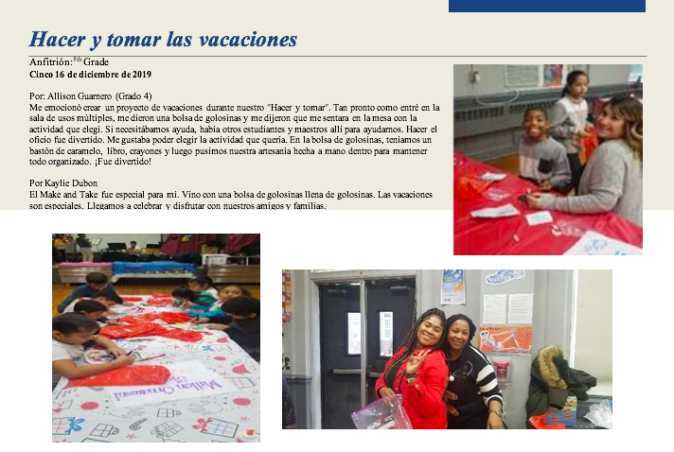

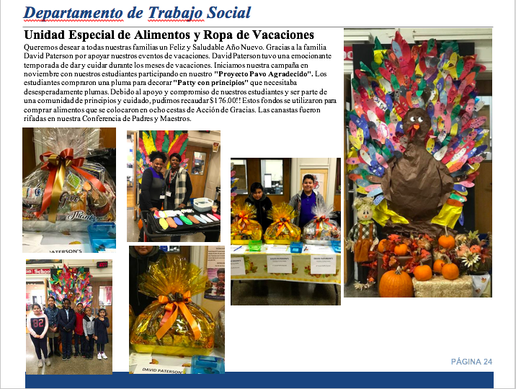

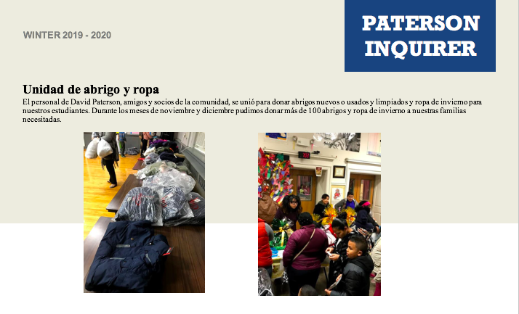

David Paterson’s Winter Concert

Concierto de invierno de David Paterson
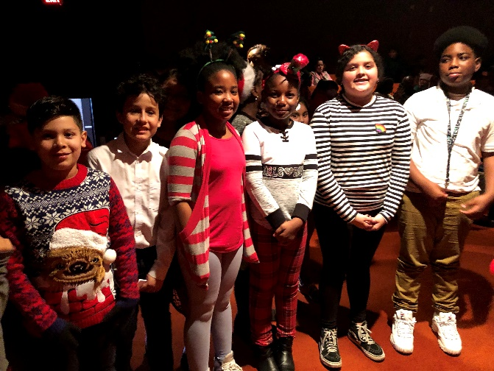
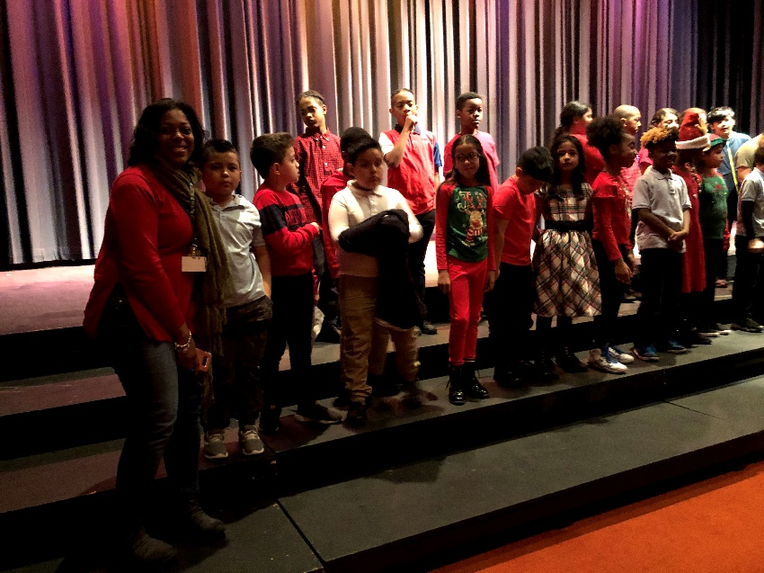

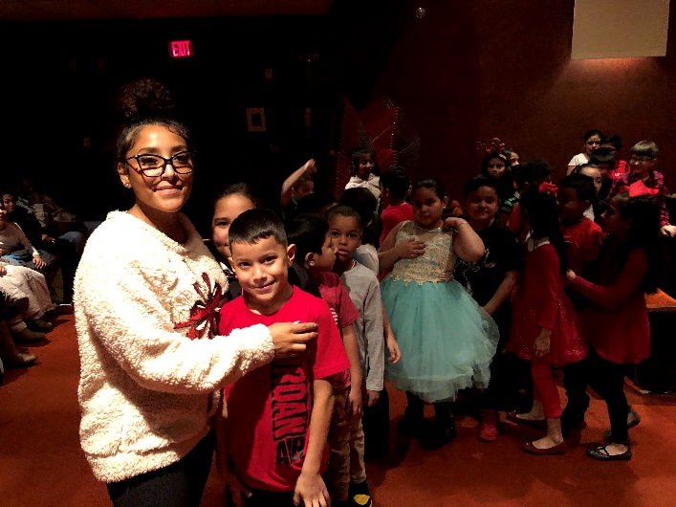
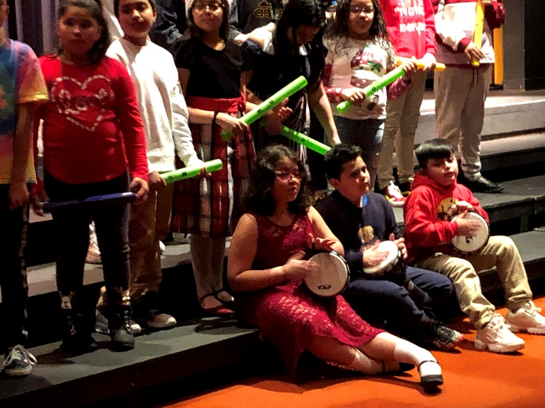

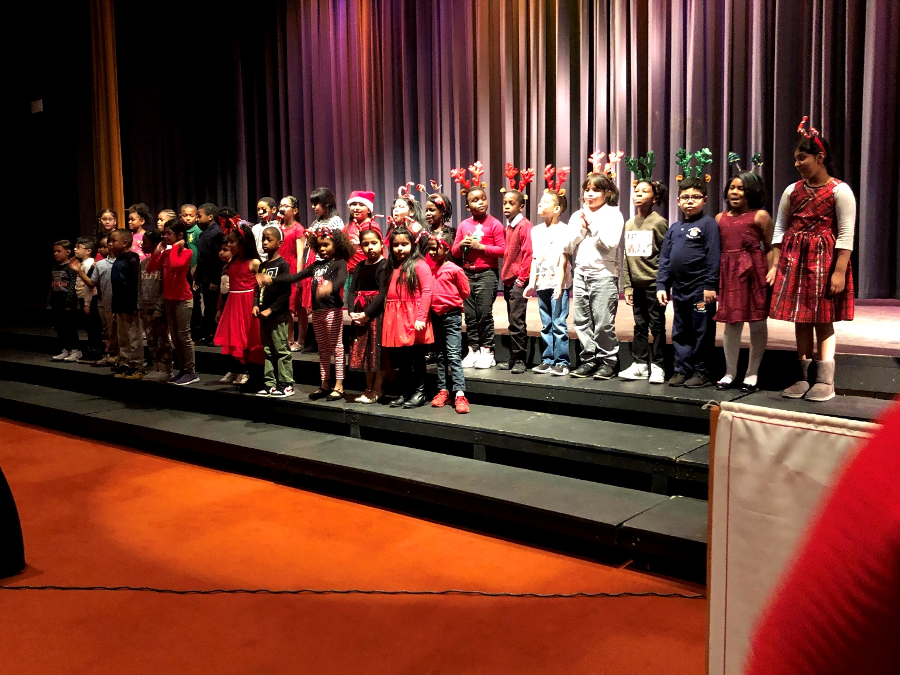

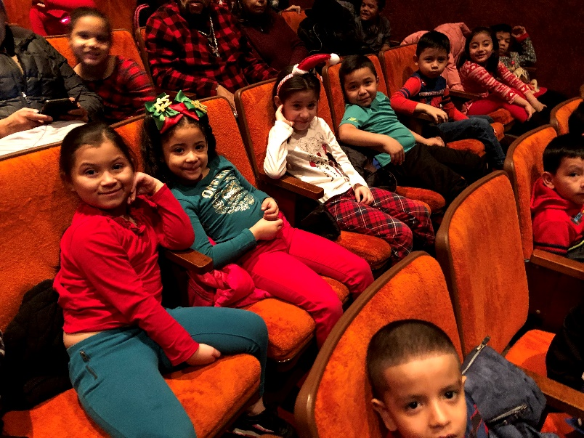
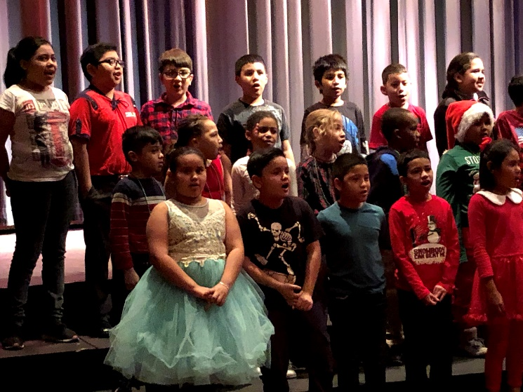

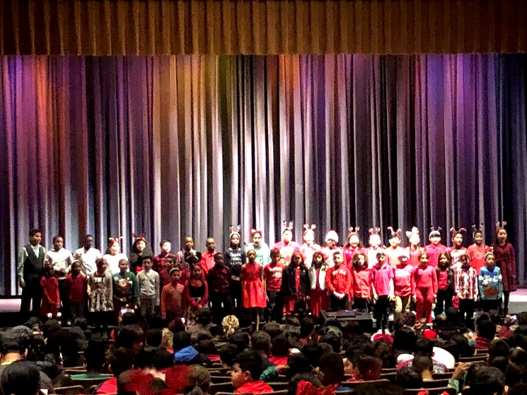

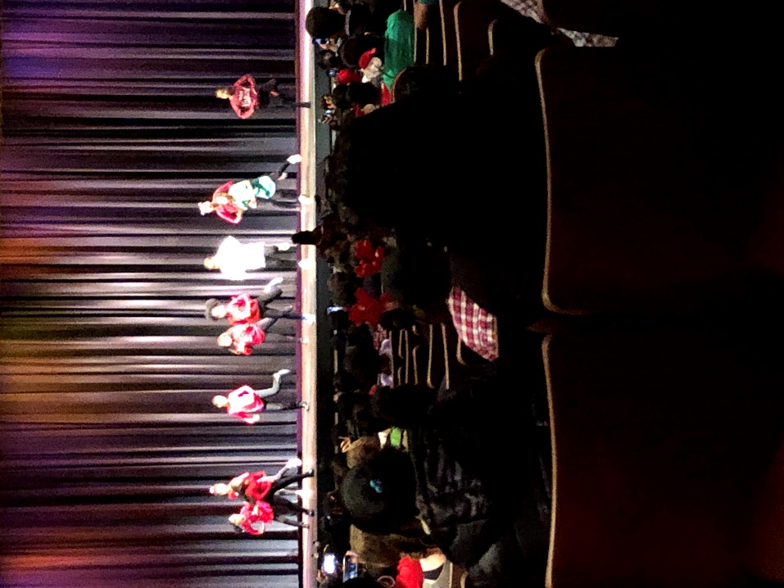

Student Ambassadors at David Paterson School

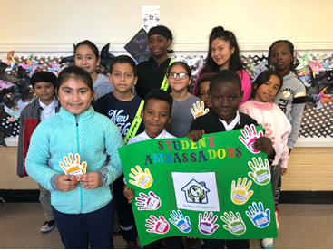
Student Ambassadors
Our student ambassadors will have a variety of opportunities to plan, organize, implement, and represent the David Paterson School in both school-wide and community projects and events. These students demonstrate the characteristics of the learner profile: balanced, caring, communicative, inquirers, knowledgeable, open-minded, principled, reflective, risk-taker, and thinkers.
Responsibilities of our student ambassadors will be to plan, organize, implement and represent our school both at school events and in the community. They are role models for all students and promote global-mindedness!

Student Ambassadors at the David Paterson School
Grade 1 | Jay'Ceion Blackmon | Grade 3 | Sara Marcilla | Grade 5 | Adachukwa Oguagha
Grade 1 | Zamari Taylor | Grade 3 | Steven Acevedo | Grade 5 | Darwin Fuentes Turcios
Grade 2 | Jasmine Serrano | Grade 4 | Rosaly Sanchez | Grade 6 | Chlore Fils-Aime
Grade 2 | Jace Huggins | Grade 4 | Anna Cubillos | Grade 6 | Ashley Calderon
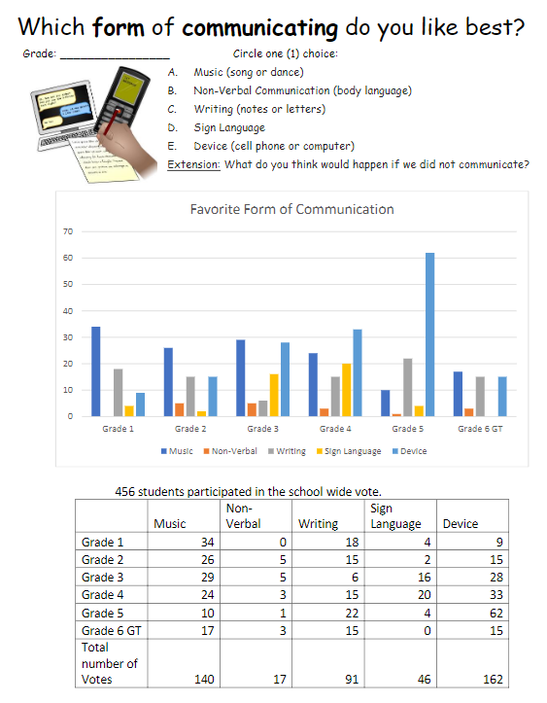
We Are Communicators!
Written by: Chlore Fils Aime
(grade 6 student ambassador)

Our student ambassadors were busy collecting data of our favorite form of communicating. Communicators was our learner profile trait for the month of December. All ambassadors in first through sixth grade met to discuss the different ways we like to communicate with one another. We came up with five different ways to communicate. They were music, non-verbal, writing, sign language and using a device.
Each of the two grade level ambassadors collected the data before school and at lunch time. We had 456 students participate in this vote! Do you want to know my favorite? I chose music as my favorite way to communicate. Which did you vote for?

Try these math problems using the data we collected. Don’t forget to Show all work!

1. How many more students like music more than sign language at Paterson School?

2. Grade 1 music has twice as many votes as which other grade?

3. Write the greatest total number of votes in expanded form.
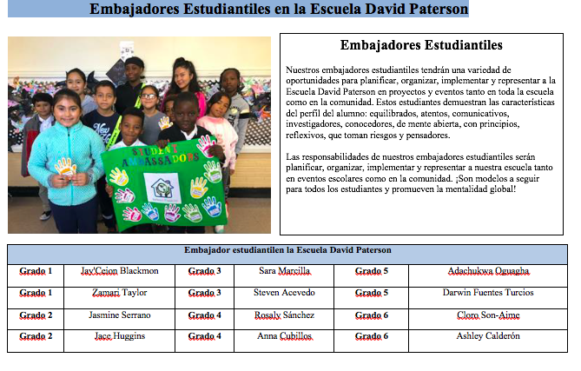

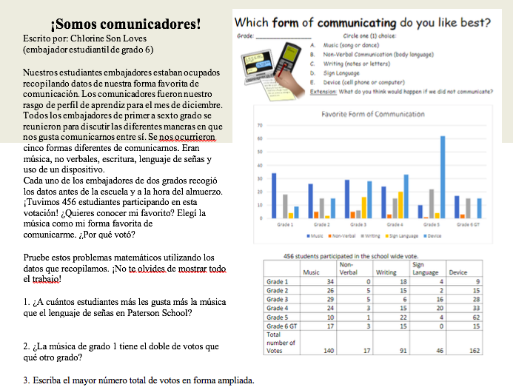

Matching Key Concepts to Questions

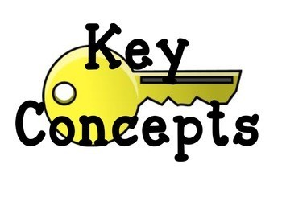

Directions: Draw a line from the key concept to its matching question.
1. Causation 1. How is it transforming?
2. Change 2. What is it like?
3. Connection 3. What are the points of view?
4. Form 4. How is it linked to other things?
5. Function 5. What are our obligations?
6. Perspective 6. How does it work?
7. Responsibility 7. Why is it the way it is?

Visible Thinking Routines
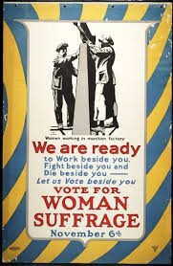
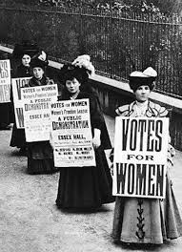
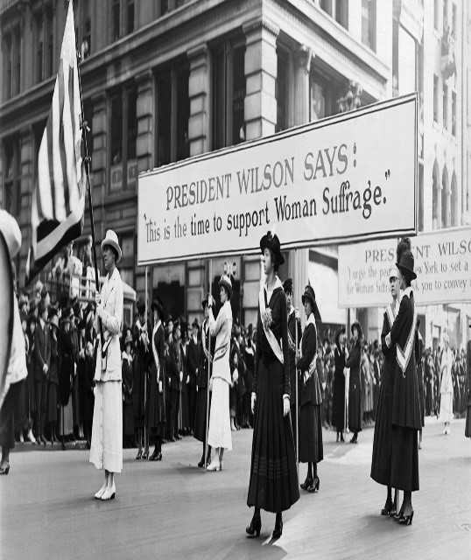

Look at the pictures above. Complete the Visible Thinking Routine See/Think/Wonder.
See | Think | Wonder
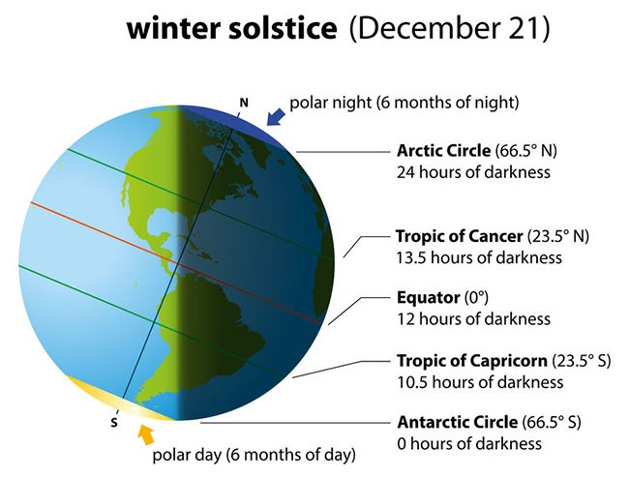

Direction: Research as many facts as you can about winter. Write your data in the table below. Then write a short story or poem about winter.

Winter Facts

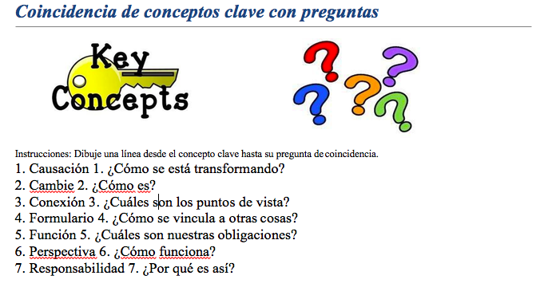

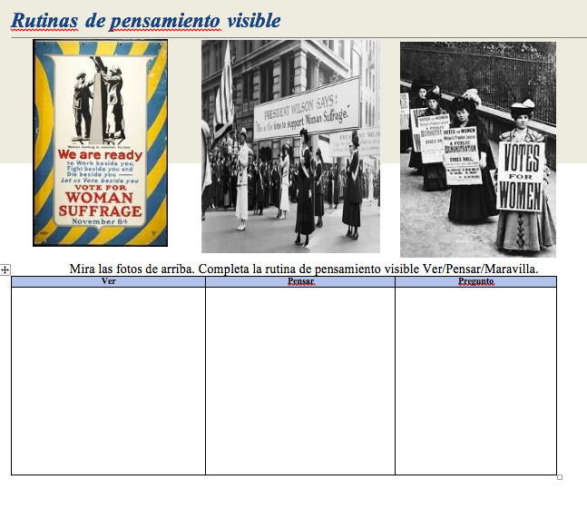

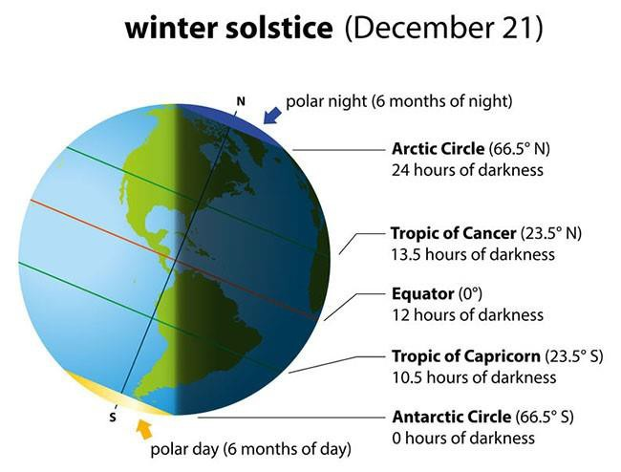

Datos de invierno

Morrison Mentors
Collaborating with our School Learning Community
Gibelly Diaz-Pena
When I was in the STEM class with Morrison Mentors, we did science and math and tested many things. The most fun part was when we went outside and played with the drones. We measured in grams and tested to see which objects would float and sink. We learned many vocabulary words such as buoyancy, mass, and triple beam balance. We even figured out what STEM means. Do you know what it stands for?

Anna Sophia Cubillos Jaramillo
My favorite activity during our STEM class was when we were using a triple balance scale to measure the mass of objects and then predict whether it would sink or float. We also used technology to maneuver a drone outside in a swimming pool.

Jose Rubi
I liked testing objects to see if they would sink or float. We measured the mass of objects using a triple beam balance. We learned how important it is to label using the correct unit such as grams . It was so much fun learning about science while testing to see if our predictions were correct.

Sharay Townsend
What I learned during our STEM session is what buoyancy and mass is. When I was at my table, I used the triple balance beam to measure the mass of objects. We then placed the objects in water to see if they would sink or float. What do you think will sink or float? Wooden block, rock, iron nail, plastic ball, or hovercraft. See me if you want to know what I found.

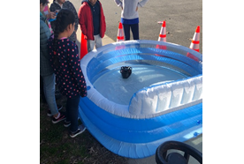
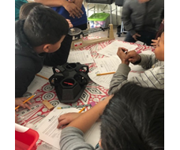
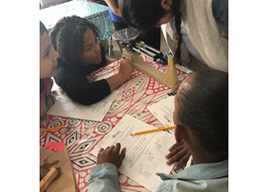

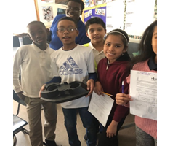
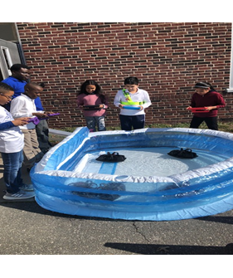

MORRISON MENTORS
COLABORAR CON NUESTRA COMUNIDAD DE APRENDIZAJE
ESCOLAR

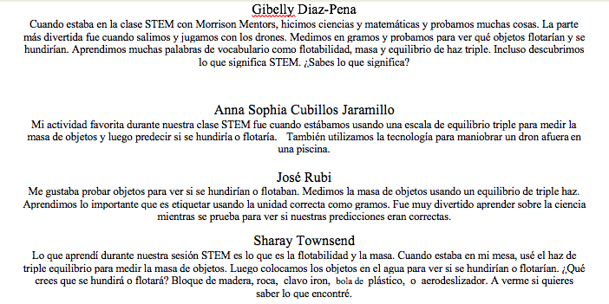

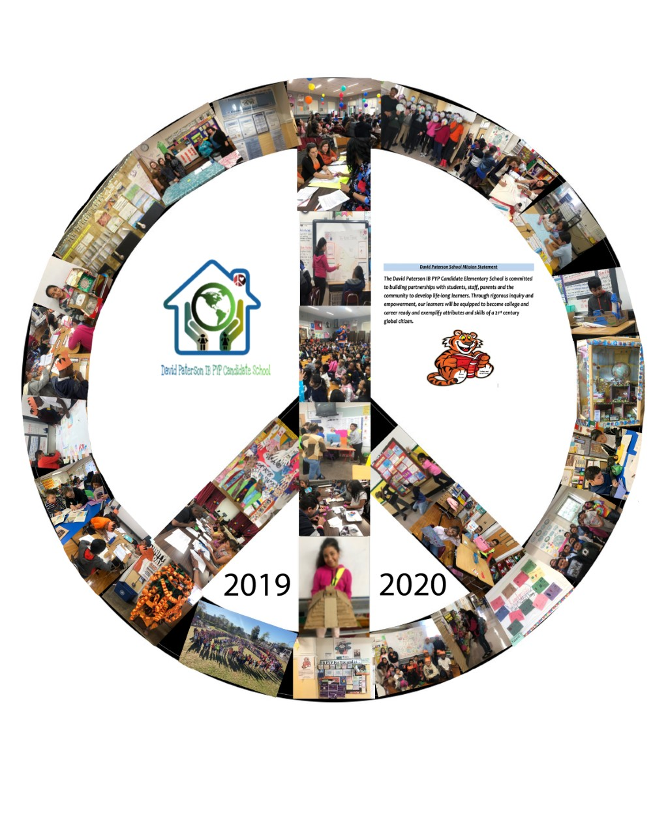

David Paterson School IB PYP Candidate School
40 Fulton Avenue
Hempstead, NY 11550
516-434-4450
www.hempsteadschools.org
Gary Rush, Principal
Keesha Keller, Asst. Principal


